QA Devops Assessment Testing Documentation

**All Manual testing included in this doc.**

When playing the game losses count as wins

**Test Case:**

Testing of the game for any inaccuracies or issues.

Select Draw

Choose Team

Click Duel

Win or lose

Increment score by 1 in corresponding category

The results of each game are properly allocated into the win or loss category.

**Bug Report:**

Win/Loss tracker incorrectly keeps score.

Select Draw

Choose Team

Click Duel

Win or lose

Score is expected to increase by 1 when winning the game

Win or lose the losses category increments by 1

Peformed on Chrome version: 113.0.5672.127 (Official Build) (64-bit)

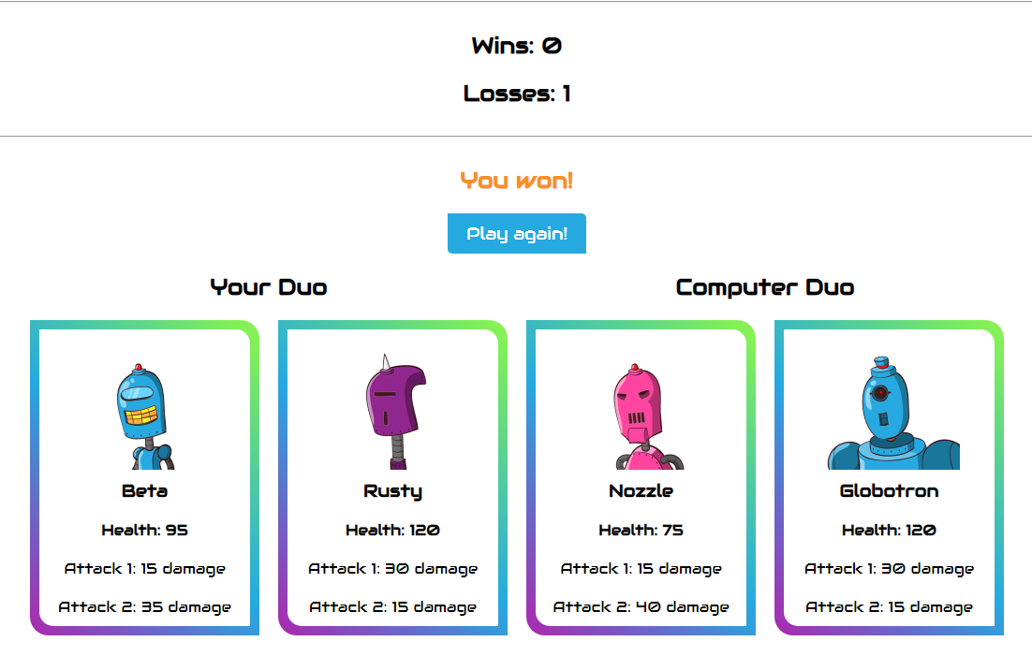

**Test Plan:**

Testing of the game for any inaccuracies or issues.

Test for See All Bots functionality

Test for Draw to randomly display bots

Test adding to duo

Test that duel works correctly

Test that score is correctly incremented

On the Duel Duo page

All tests have passed or a bug report written for a failure

Game should run on any browser or platform